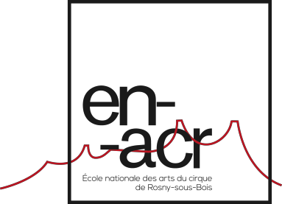
Parental Permission for Minor Children
(under 18 years of age)

I, the undersigned, Mr or Ms (Last Name, First Name) Postal address Telephone number
Email address

Acting in the capacity of a father, mother, or guardian, authorizes (my child):

Child’s last name Child’s first name
Child’s date of birth

To take part in the ENACR 2020 entrance examination. I release the Rosny-Sous-Bois National School of Circus Arts from any and all responsibilities and liabilities involving my child, during his/her extracurricular activities and during his/her time in the accommodation.
Location , Date

Signature of the child’s parent or guardian

